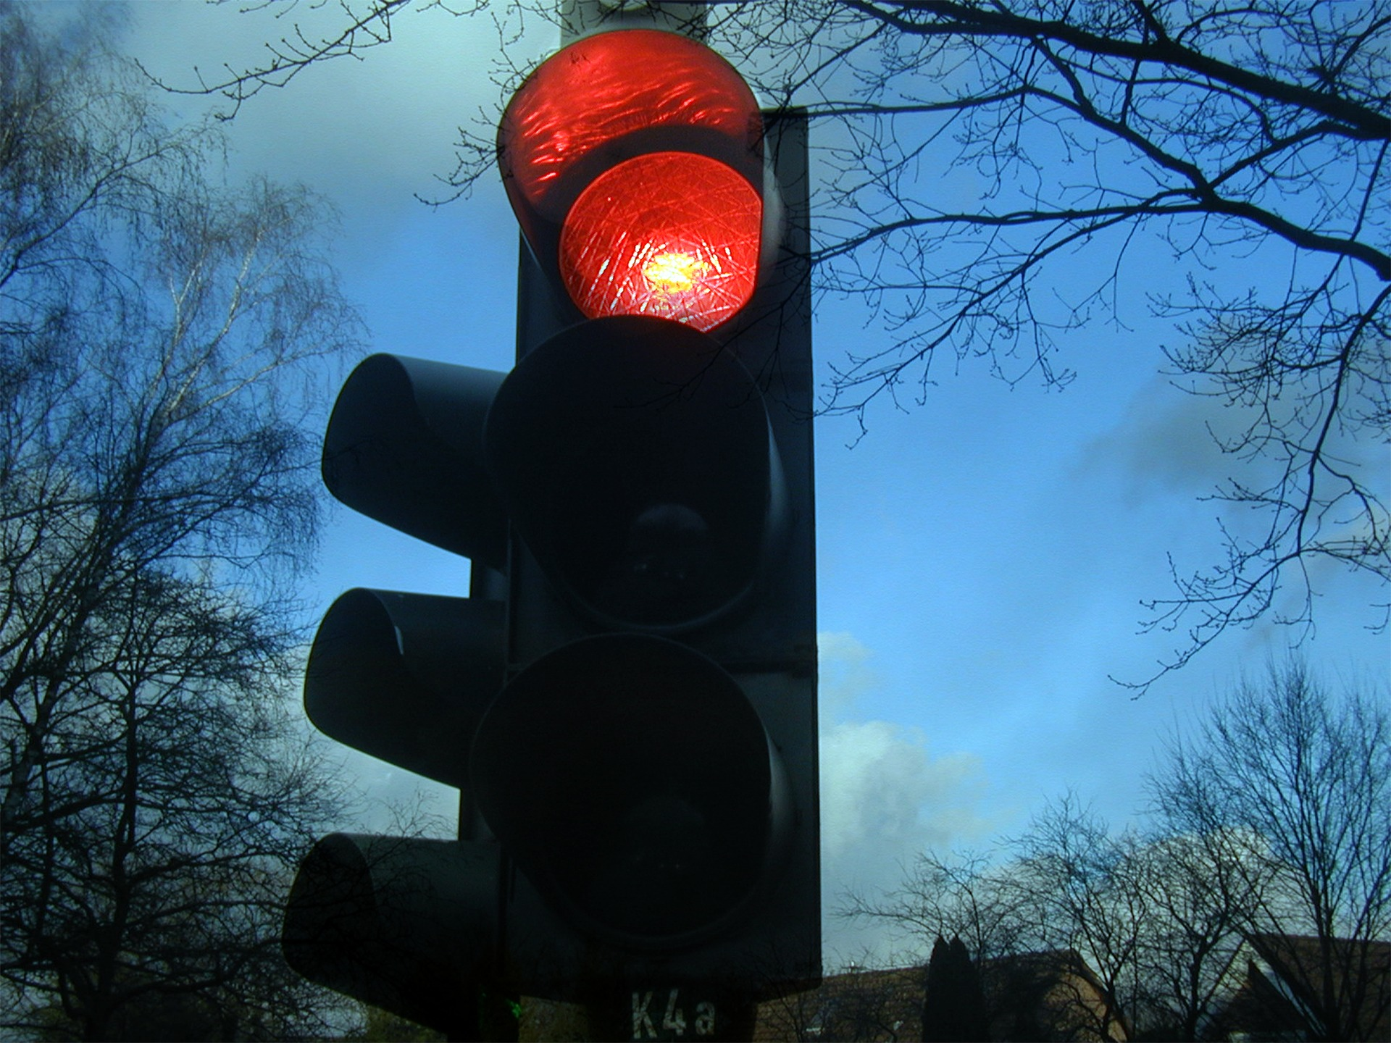

TRAFIC CONTROL SYSTEM

* **Project Name:** Traffic Light Control System
* **Name:** [ARYAN RAJ PANDEY]
* **Roll No:** [202401100300070]
* **Date:** [11/3/2025]

|  |
| --- |
| introduction |

**The Traffic Light Control System is an AI-based solution that dynamically adjusts traffic signals based on real-time traffic density. The goal is to optimize traffic flow and reduce congestion using sensor data.**

|  |
| --- |
| methodology |

* The system reads traffic density from a dataset (traffic_data.csv).
* It determines the duration of Red, Yellow, and Green signals based on the traffic load.
* The program continuously updates the signals in a loop to simulate real-time traffic control.
* The process follows the standard **Red → Yellow → Green** sequence.

|  |
| --- |
| code |

import time

import pandas as pd

# Load dataset

file_path = "/mnt/data/traffic_data.csv"

df = pd.read_csv(file_path)

# Function to determine signal timing

def get_signal_timing(traffic_density):

if traffic_density < 1000:

return {'Red': 5, 'Yellow': 3, 'Green': 10} # Low traffic

elif 1000 <= traffic_density < 5000:

return {'Red': 8, 'Yellow': 3, 'Green': 7} # Medium traffic

else:

return {'Red': 10, 'Yellow': 3, 'Green': 5} # High traffic

# Simulating Traffic Light System

while True:

latest_traffic = df.iloc[-1] # Get latest traffic data

traffic_density = latest_traffic['UniqueVisitors']

timings = get_signal_timing(traffic_density)

print(f"\nTraffic Density: {traffic_density}")

for light in ['Red', 'Yellow', 'Green']:

duration = timings[light]

print(f"{light} Light ON for {duration} seconds")

time.sleep(duration) # Wait for light duration

print("Cycle Restarting...")

time.sleep(2) # Small delay before restarting

|  |  |  |
| --- | --- | --- |
| Output/Result |  | References/Credits |
|  | On the References tab, in the Citations & Bibliography group, click Insert Citation for the option to add sources and then place citations in the document.  When you’ve added all the citations you need for your report, on the References tab, click Bibliography to insert a formatted bibliography in your choice of styles.  And you’re done. Nice work! |

3. GITHUB LINK

[https://github.com/Aryan-rtp/Traffic_light_control_202401100300070.git]